PROJECT REPORT TEMPLATE TEAM ID-NM_ID: 564D81863328279A5454A72CAE401F4C

Recruiting Assistance for the HR managers.

1 .INTRODUCTION:

PROJECT OVER VIEW:

In this project, we use custom objects, relationships, page layouts to give the HR team easy

access to data they need on an existing recruitment app.

To make the existing app more efficient for the HR team we create custom objects and

relationships to store and access the data more efficiently. We install an unmanaged package in

the org to get metadata that acts as existing data in the recruitment app.

2.PROJECT DEFINATION AND DESIGH THINKING:

EMPATHY MAP:

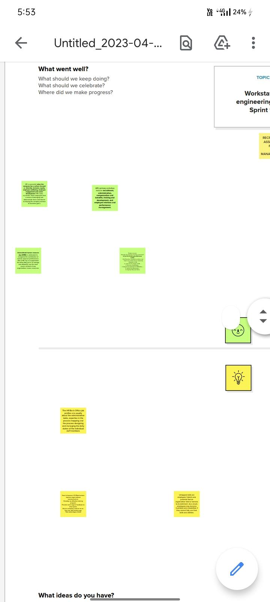

2.2 IDEATION AND BRAINSTORMING MAP:

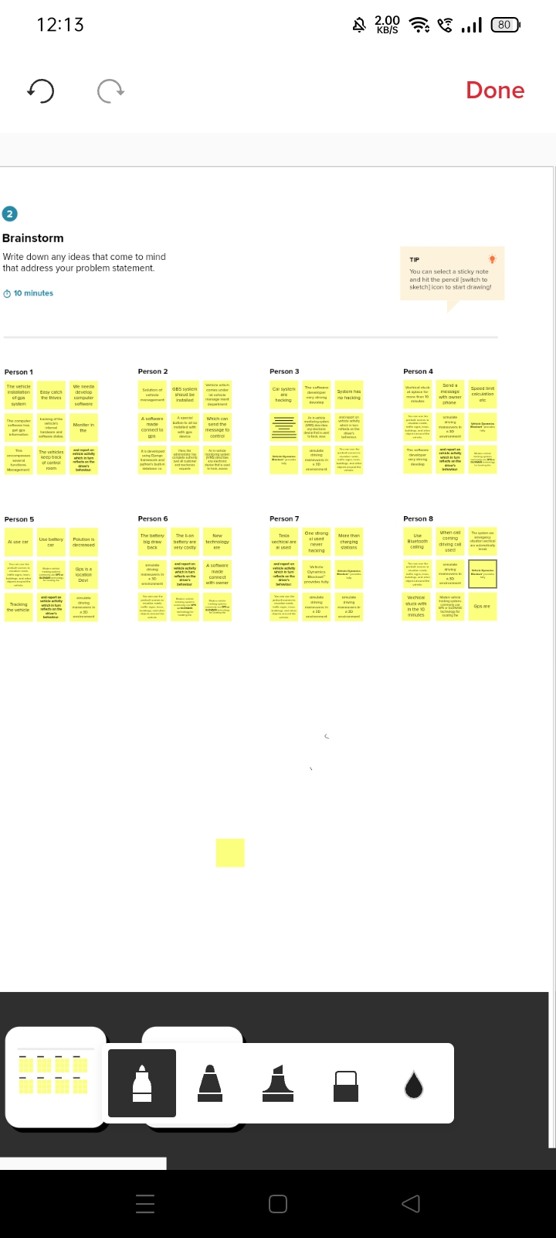

3.3. RESULTS:

3.1 DATA MODEL

| Objects name | FIELD IN THE OBJECT | |
| --- | --- | --- |
| FIELD LABEL | DATA TYPE |
| OBJECT 1 | City | Text |
|
| Start date | Date and time |
| OBJECT 2 | Event name | Feild and relationship |
| I 'd | Auto number |
| Phone | Phone |
|  | Tickets | Picklist |
| Bio | Text atea |
| Mail | Mail |

ACTIVITY AND SCREENSHOT:

Milestone-1[ salesforce] :

A developer org is created in salesforce .signup from is filled and a new user name and password is created .account is activated by the email received and the account gets verified and a developer account gets created.

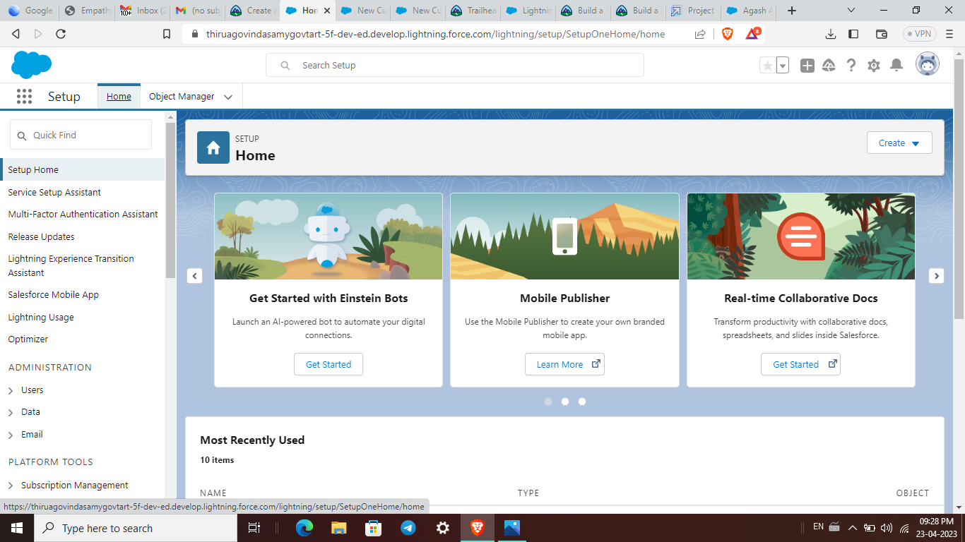

Milestone-2:

Package Installation:

Package installation for Recruiting App

In Salesforce, a package is a collection of Apex classes, triggers, Visualforce pages, and other

components that can be installed into an organization. There are two types of packages: managed

and unmanaged. Managed packages are developed and distributed by ISVs (Independent

Software Vendors) and can be installed from the Salesforce AppExchange, while unmanaged

packages are created and distributed by Salesforce administrators within an organization. To

install a package, an administrator can navigate to the AppExchange, find the desired package,

and click the "Install" button. The administrator will then be prompted to log in to their

Salesforce organization and provide permission to install the package.

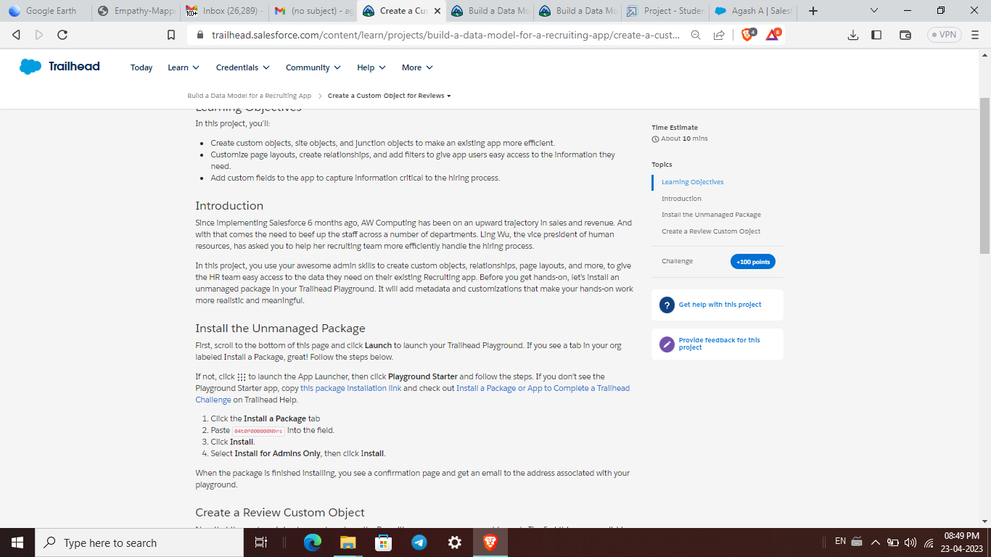

Milestone- 3 : Object:

Salesforce objects are database tables that permit you to store data that is specific to an

organization. It consists of fields (columns) and records (rows).

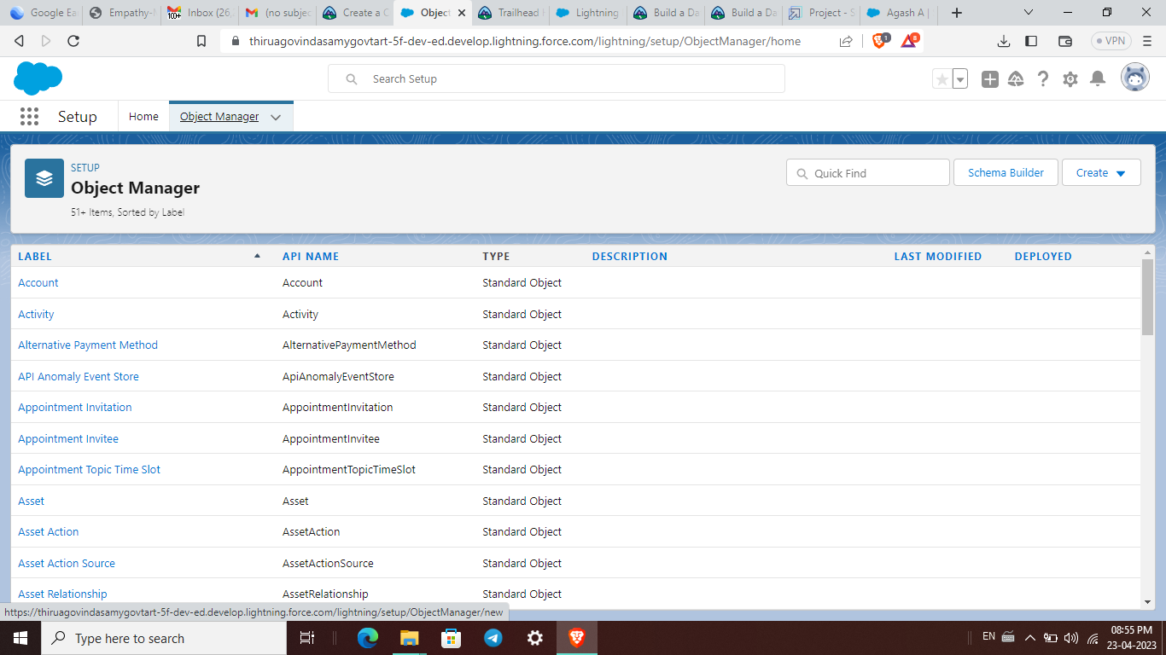

Activity-1:

Create a custom object for Job Posting Sites.

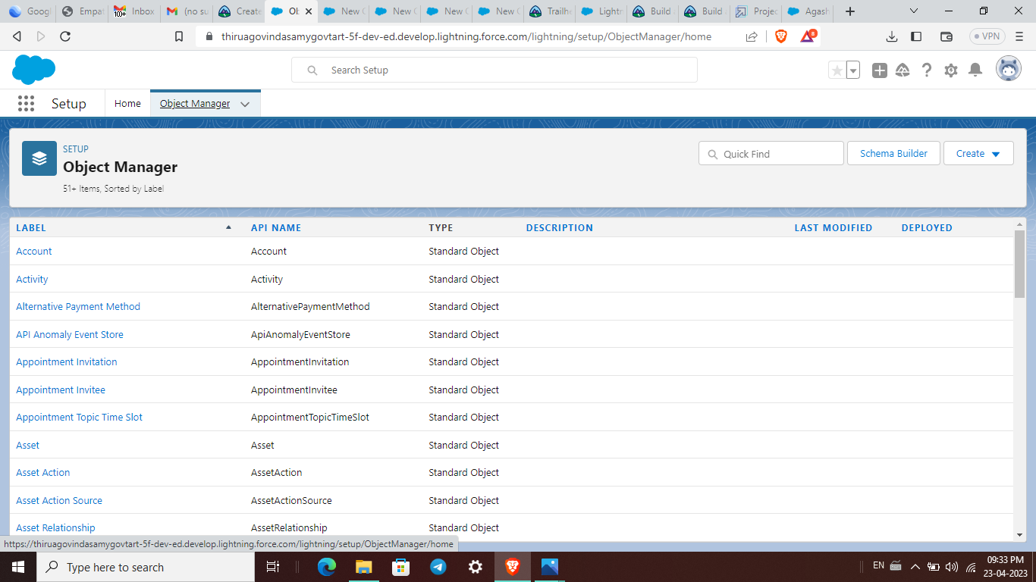

Activity-2

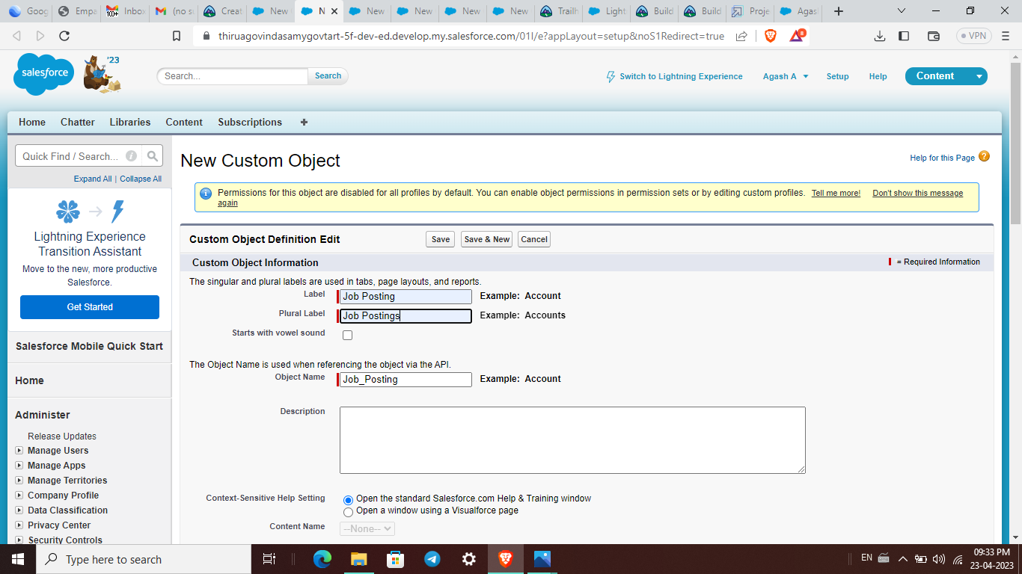

Milestone-4:Tab:

Activity :

How to create a tab.

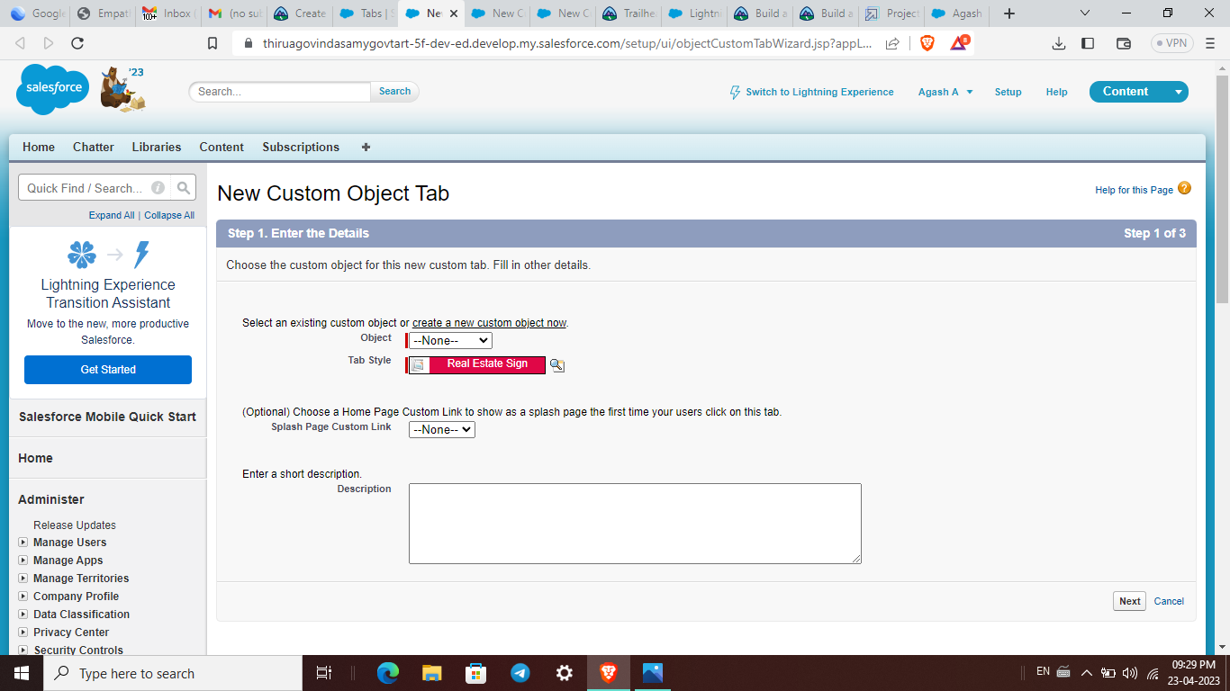

Milestone-5: Fields:

Activity-1

Create New Field for Job Posting site.

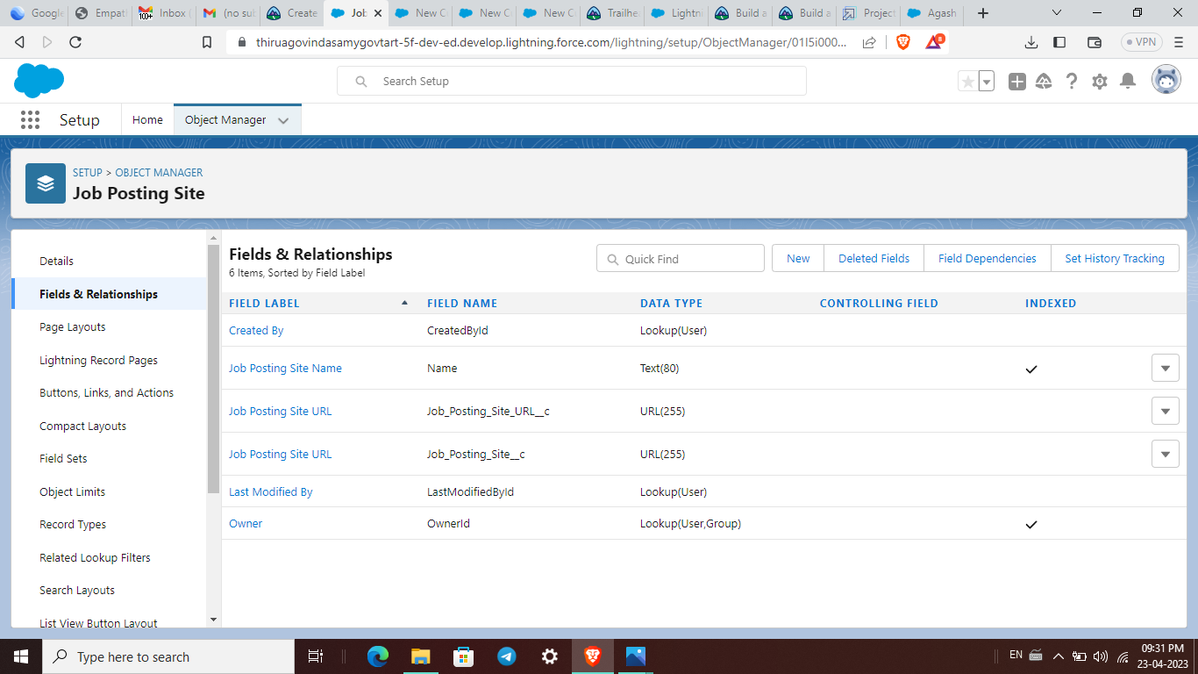

Milestone-6: Junction Object:

Activity

Creating a custom junction object :

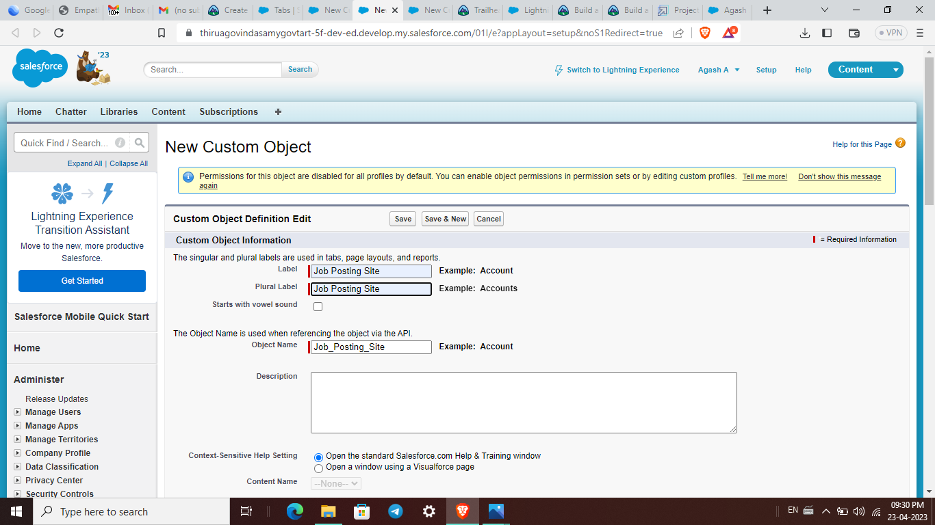

Milestone-7: Page layout:

Create a Page layout for Review Object.

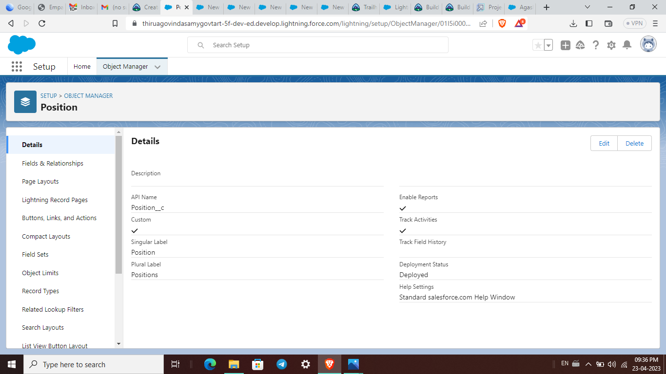

Milestone 8 : Validation Rules:

Create a Validation rule For Technical Site Checkbox is equal to True.

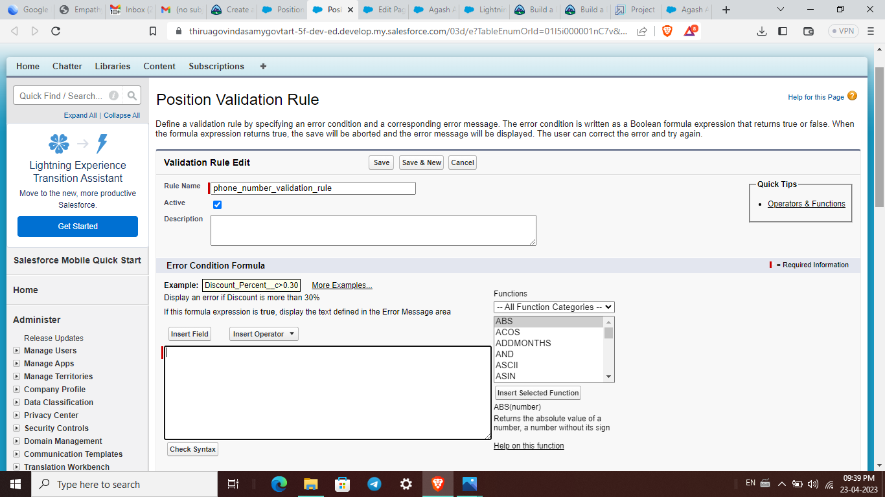

Milestone 9 : Profile:

Create a profile with the profile name as “Sales profile.

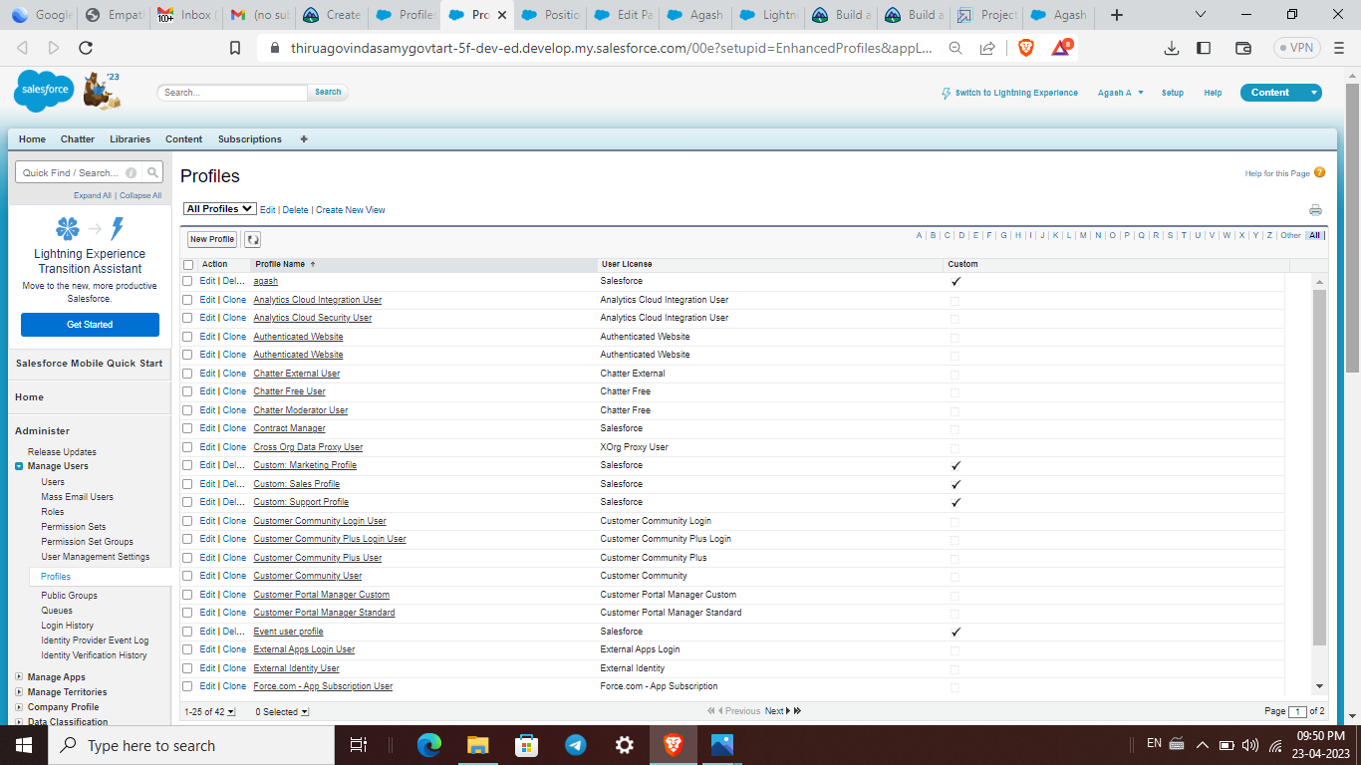

Milestone 10: User:

Using the tab a new profile, salesforce user is created.

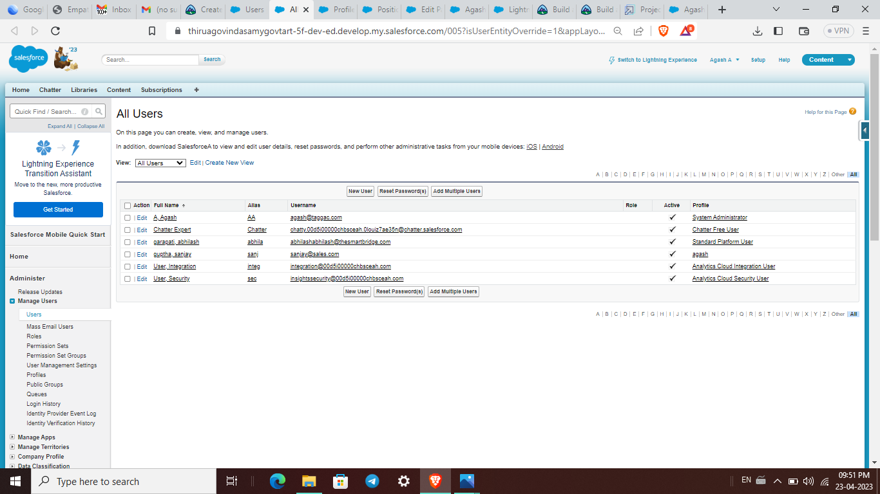

Milestone 11 : Permission set:

the permission sets tab as created the Event permits.

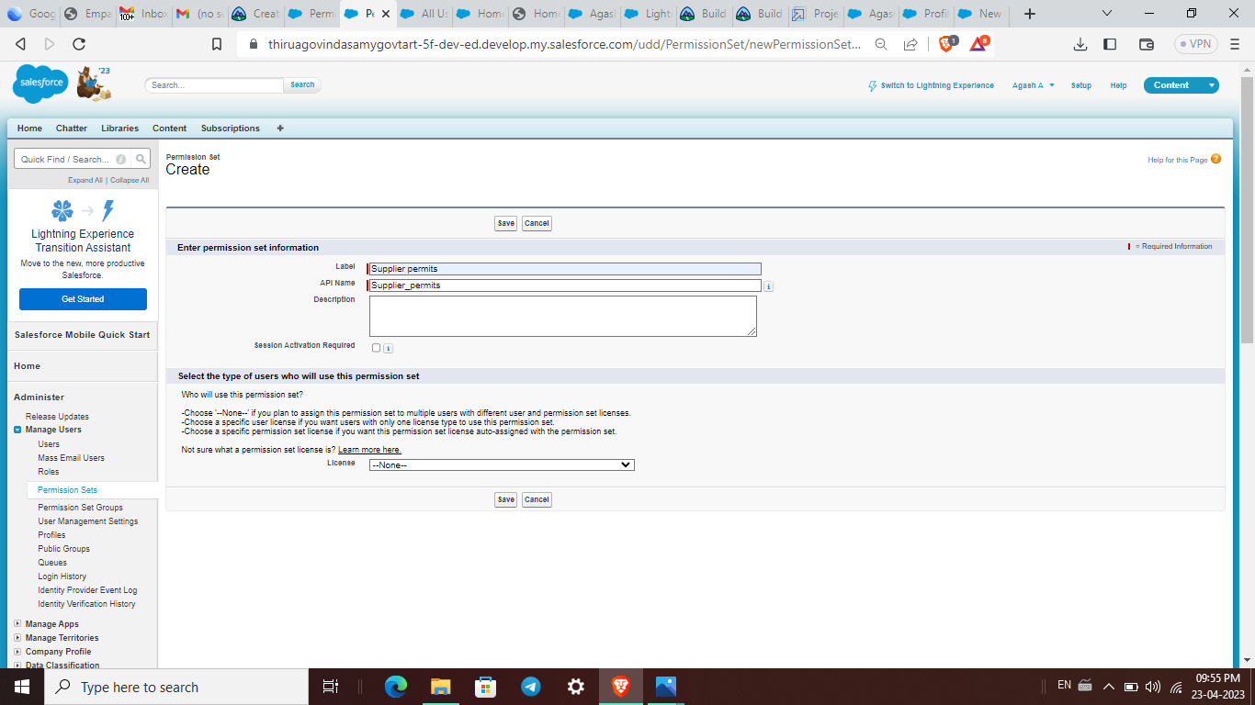

Milestone 12: Reports:

We are created the ATTENDEES WITH EVENTS FOR THE REPORTS.

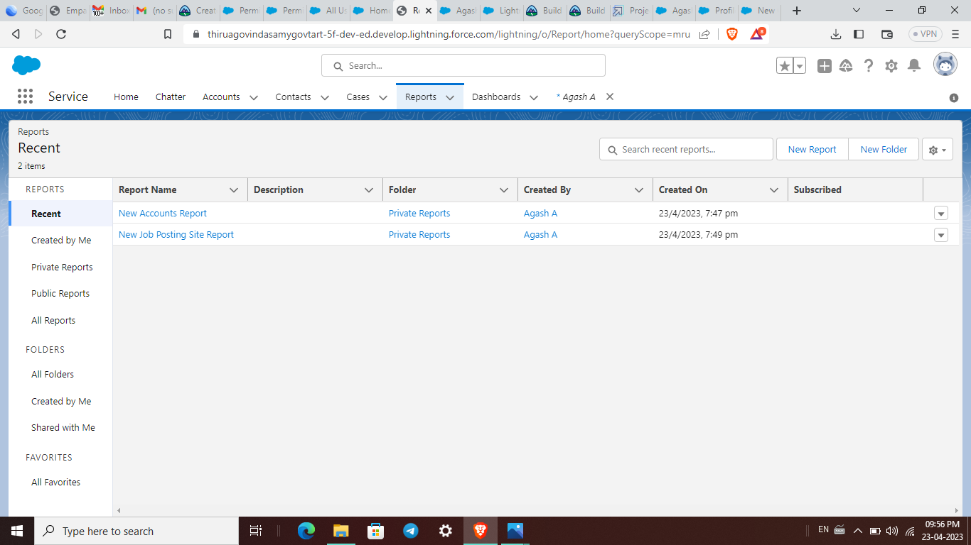

4.Trailblazer Profile URL:

Team lead (A AGASH) – https://trailblazer.me/id/agash93

Team member 1 (GOPINATHAN) – https://trailblazer.me/id/gopinath23

Team member 2 (ELANGOVAN C) – https://trailblazer.me/id/elangovan13

Team member 3 (GUNAL A) – https://trailblazer.me/id/gunal46

5.

5.1ADVANTAGES:

They often help manage job trainings where employees can learn transferable skills. As an HR assistant, you might help provide employees with performance reviews that offer valuable information about their work. This allows them to identify areas of improvement in their skills and knowledge.

5.2DISADVANTAGES:

The recruitment process saves lots of time, energy, and resources for the organization but also has some drawbacks. The most notable disadvantage of recruitment is that it leads to the stagnation of the work in the organization.

6.APPLICATIONS:

Human resources software assists with managing people, information and processes. Used by businesses of all sizes, HR software is designed to help both managers and employees work more efficiently while reducing errors, ensuring compliance and increasing productivity

7.FUTURE SCOPE:

There is and will continue to be the creation and diversification of HR job roles. As listed in the future jobs section, there will be a need for specialists in areas of data analysis, benefits creation, remote work development, and strategy building, etc.

8.CONCLUTION:

On the one hand, the Soft and Hard Human ResourceManagement influence on the business and lets them development rapidly. Itcan improve employee's motivation in a business and pay attention tocompany's policy and law respectively, which can increase the efficiency ofcompany and get higher profits.